**Angular JS**

**Hello world**

Download > nodej.org

Download > visual studio code

>node –-version

>npm install –g @angular/cli  
>ng –-version

>code

>ng new hello-world

D:\JS\hello-world>code .

D:\JS\hello-world>ng serve

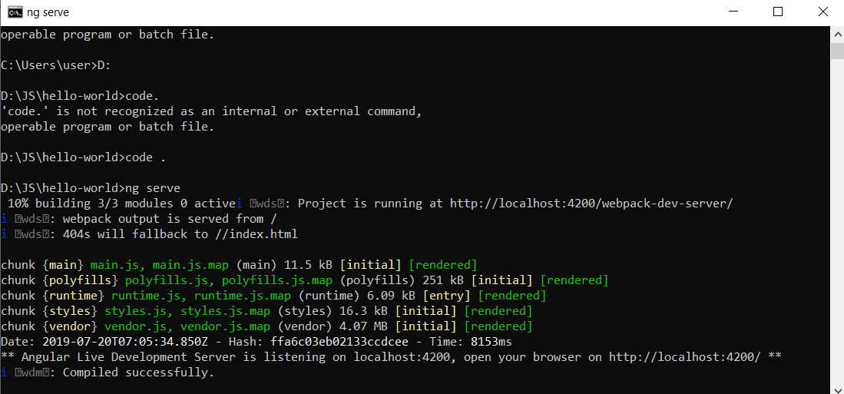

**Typescript**

>npm install –g typescript

>tsc --version

D:/JS>mkdir ts-hello

D:/JS>cd ts-hello/

D:/JS/ts-hello>code main.ts

Write a simple code :   
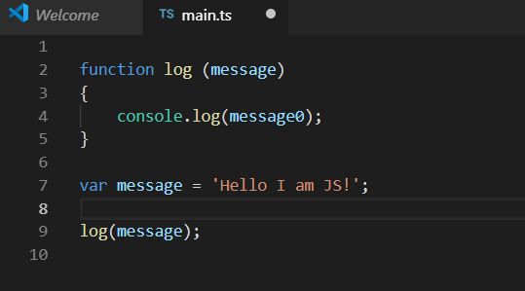

D:/JS/ts-hello>tsc main.ts

D:/JS/ts-hello>code main.js

D:/JS/ts-hello>node main.js

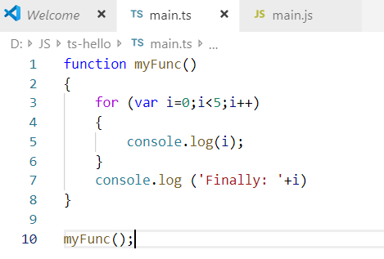

D:\JS\ts-hello>tsc main.ts | node main.js

**Types**

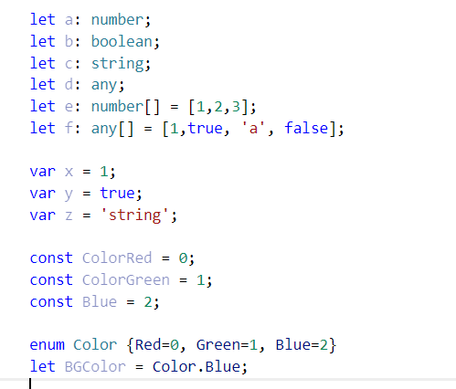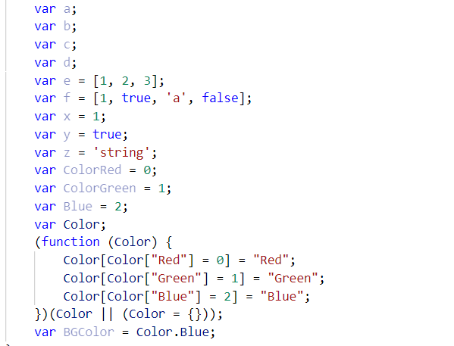

**Type assertions**

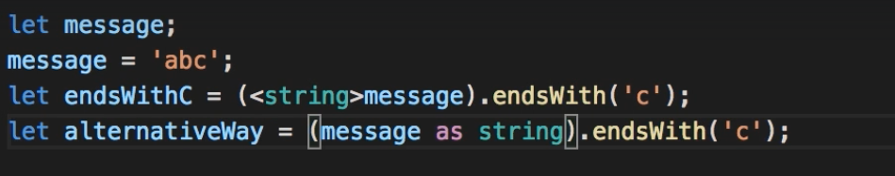

**Arrow functions**

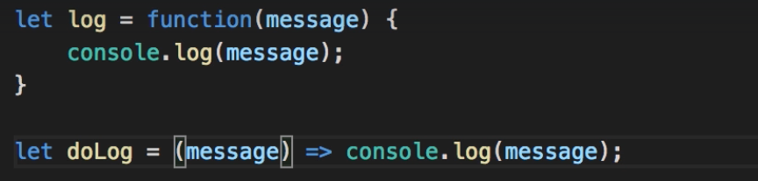

**Interfaces**

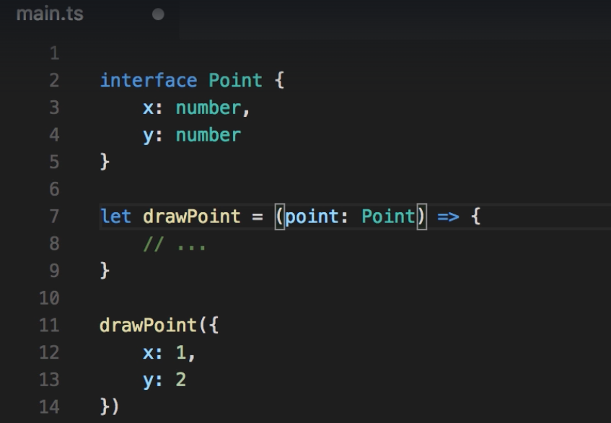

**Classes**

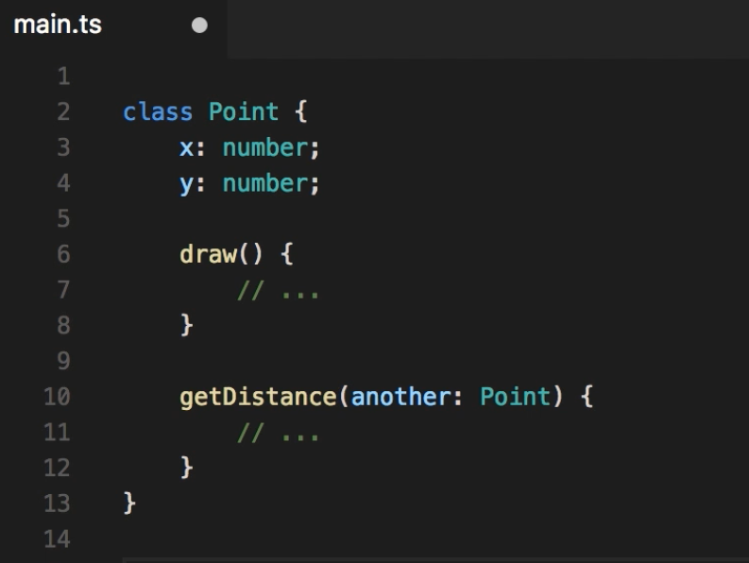

**Objects**

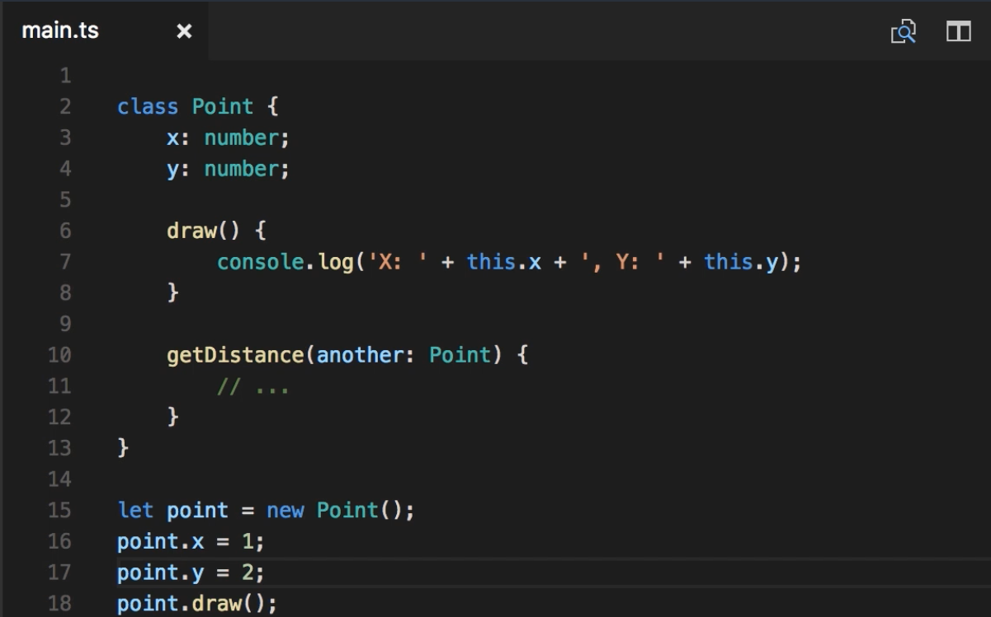

**Constructor**

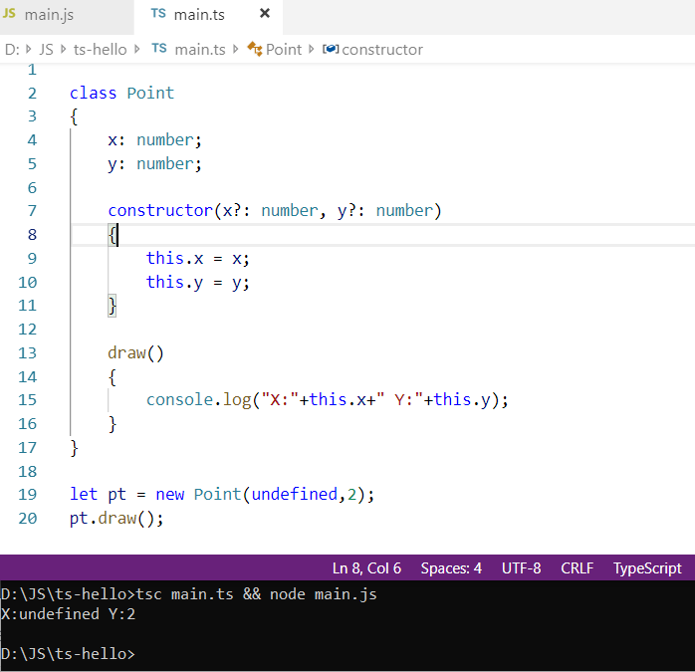

**Access modifiers**

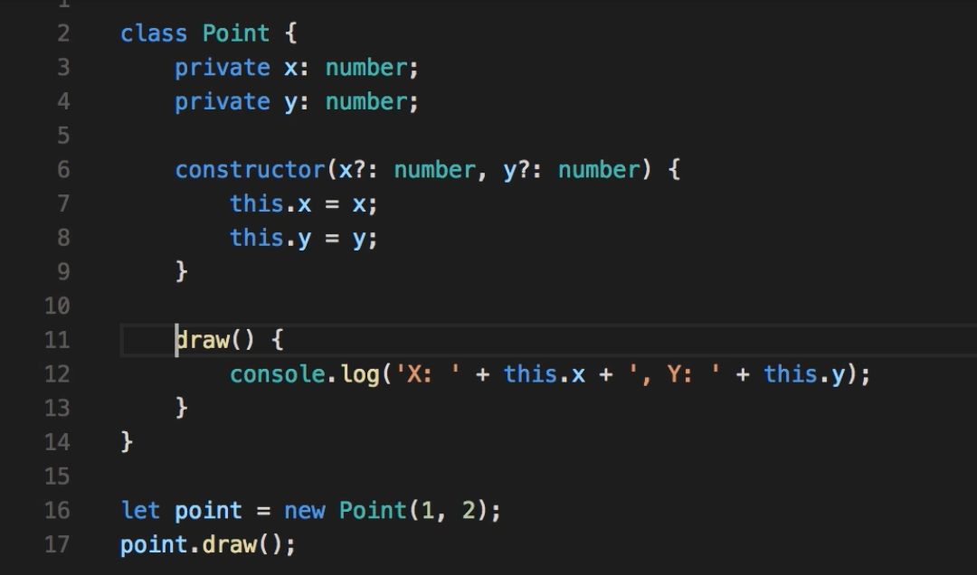

**Access modifiers in Constructor parameters**

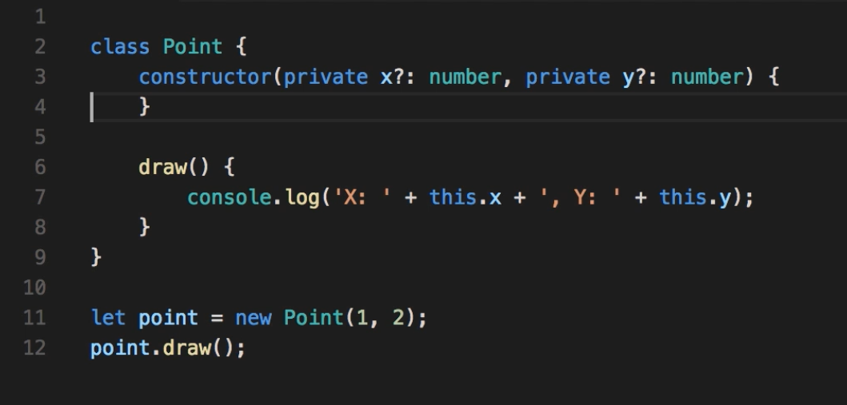

**Properties**

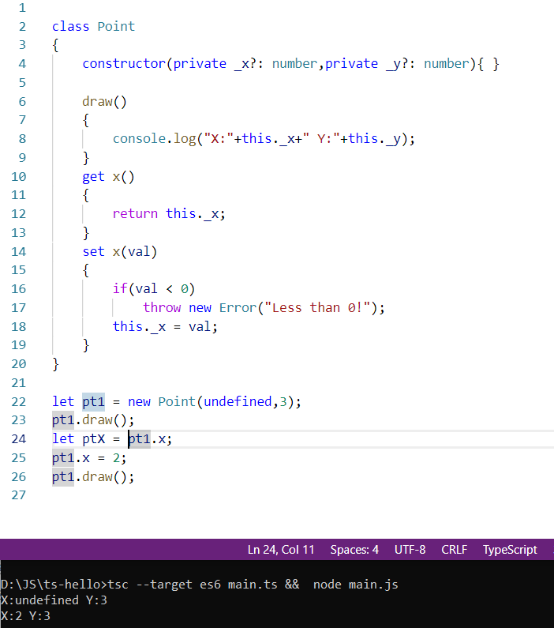

**Modules**

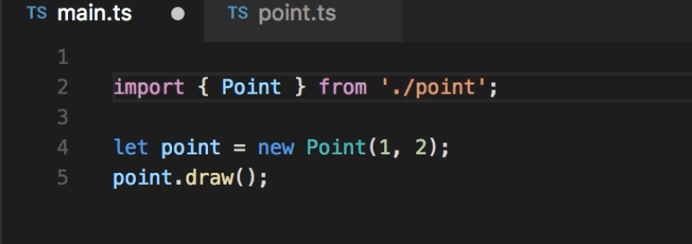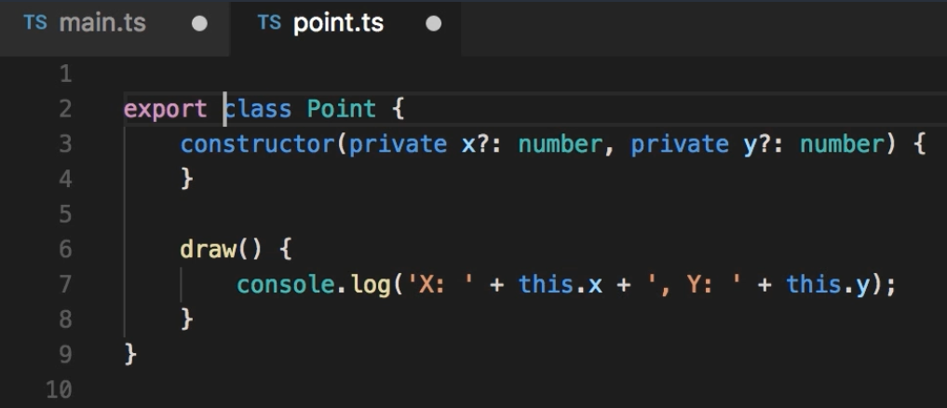

**Facebook likes**

// main.ts

import { LikeComponent } from './like.component';

let component = new LikeComponent(5, false);

component.onClick();

console.log(`likesCount: ${component.likesCount}, isSelected: ${component.isSelected}`);

// like.component.ts

export class LikeComponent

{

constructor(private _likesCount:number, public _isSelected:boolean)

{}

onClick()

{

this._likesCount += (this.isSelected) ? -1 : +1

this._isSelected = !this._isSelected;

}

get likesCount()

{

return this._likesCount;

}

get isSelected()

{

return this._isSelected;

}

}



**Generating components using angular CLI**

**Ctrl + `** to open terminal in VSCode

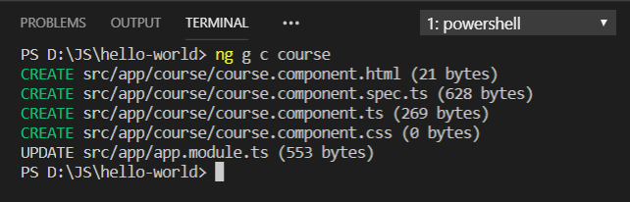

Course component created

**Components**

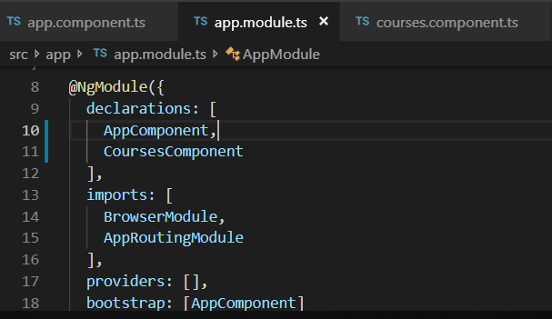

// courses.component.ts

import { Component } from '@angular/core';

@Component({

selector: 'courses', // <courses>

template: `

<h2>{{title}}</h2>

<ul>

<li *ngFor="let course of courses" style="padding:15px; border: 1px solid black;width:30%;margin:auto">

{{ course }}

</li>

</ul>

`

/*'<div style="margin-left:100px;padding:20px; border: 1px solid black;width:30%;">

<a href="#" style="text decoration:none; color:red"> {{course}} </a>

</div>'

*/

})

export class CoursesComponent

{

title = "List of Courses";

courses = ["Course1","Course2","Course3"];

}

**Services**

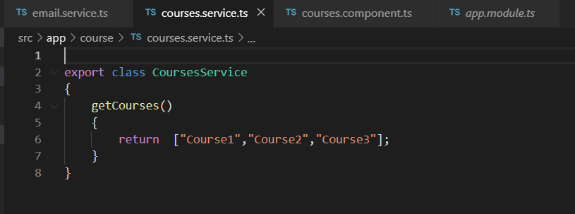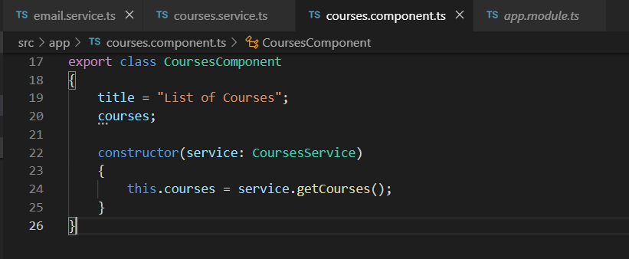

**Dependency injection**

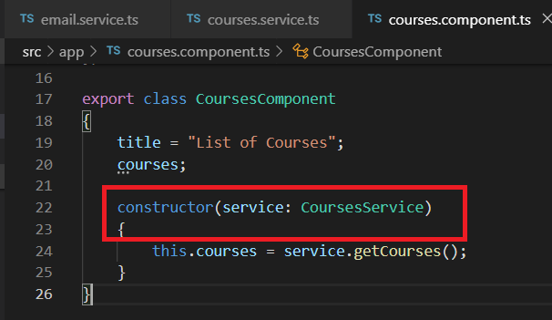

**Generating Services using angular CLI**

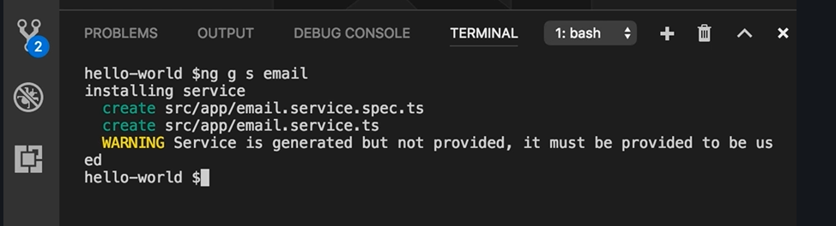

Email service created

**Property binding**

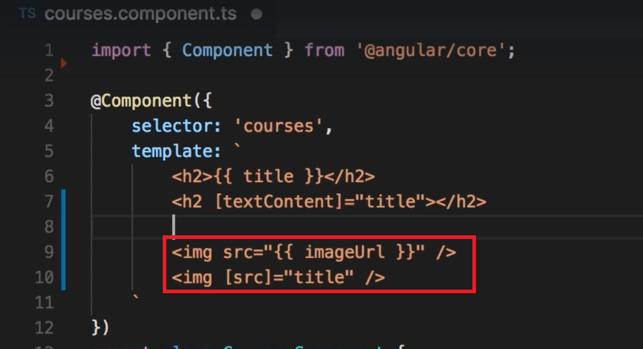

**Attribute binding**

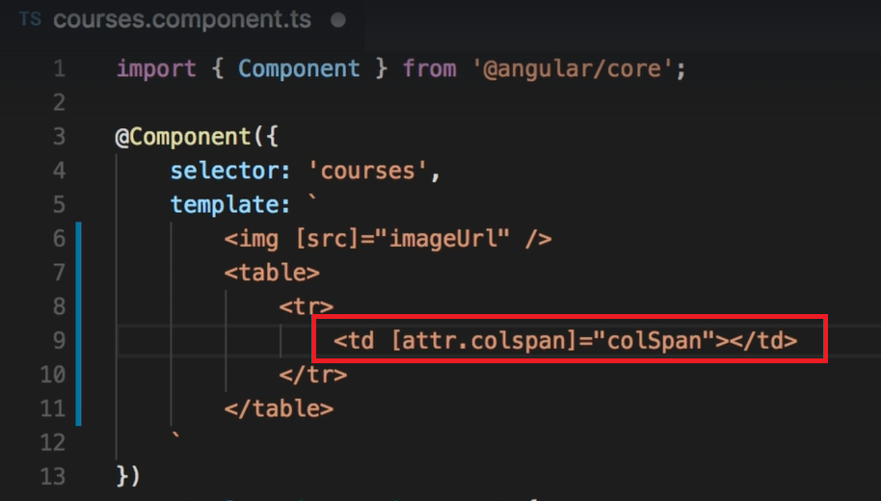

**Bootstrap**

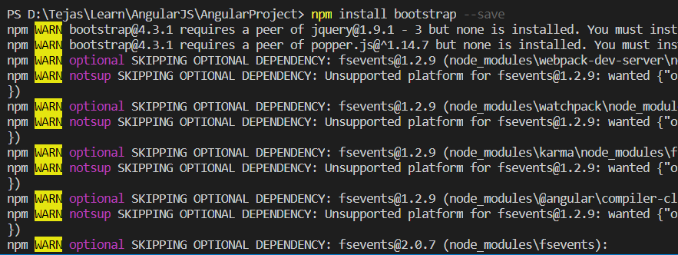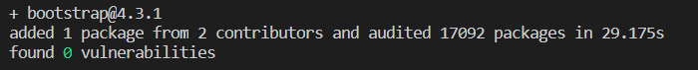

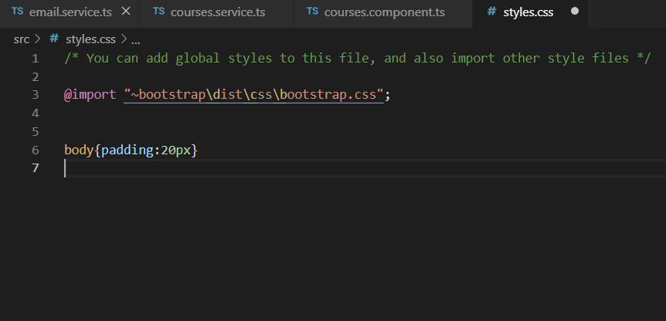

@import "~bootstrap\dist\css\bootstrap.css";

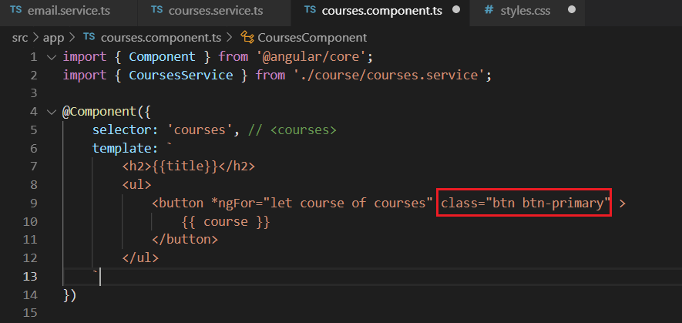

**Class binding**

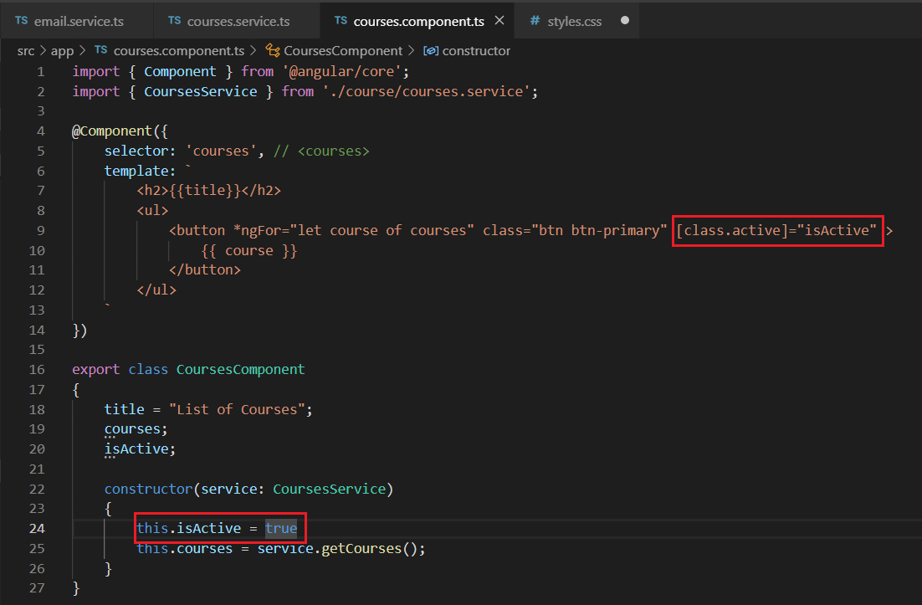

**Style Binding**

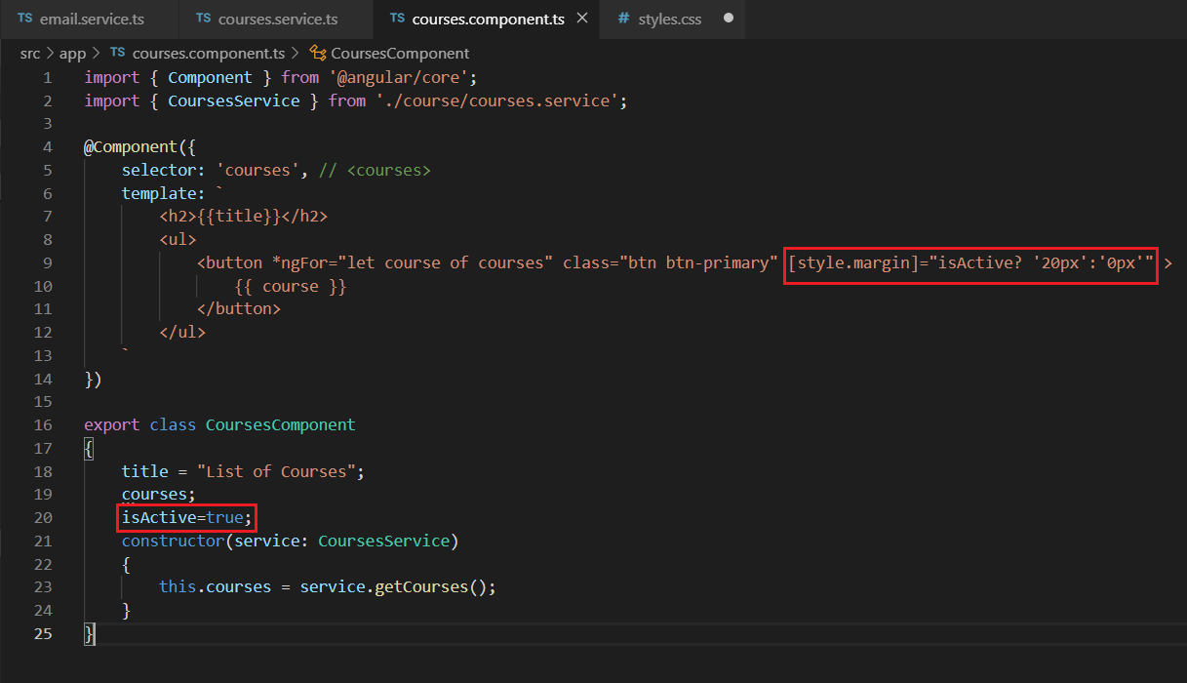

**Event Binding**

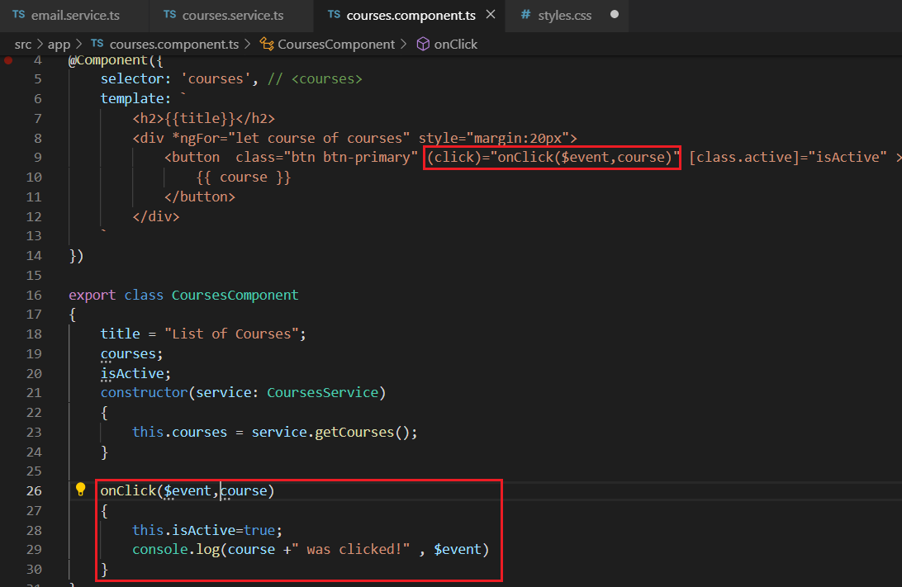

**Event Filtering**

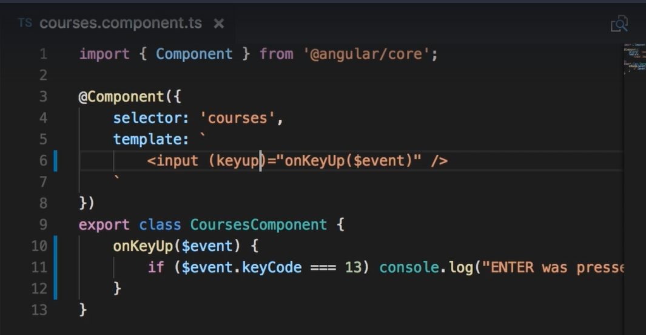

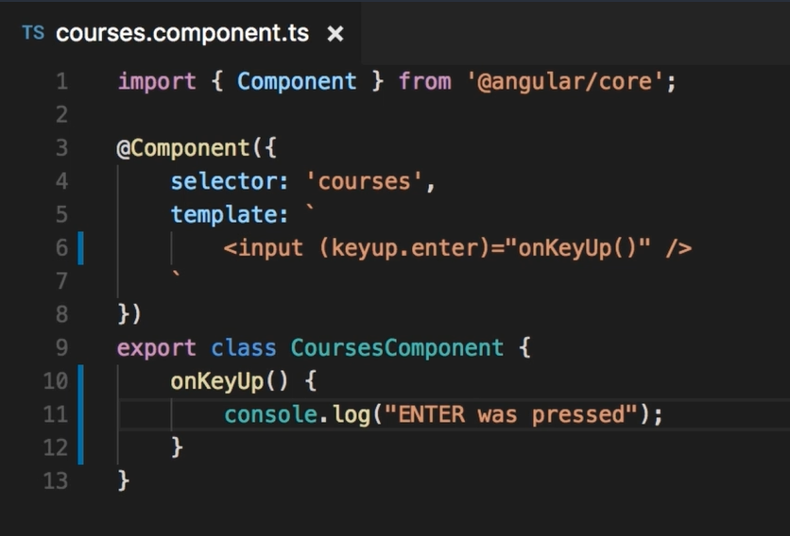

**Template variables**

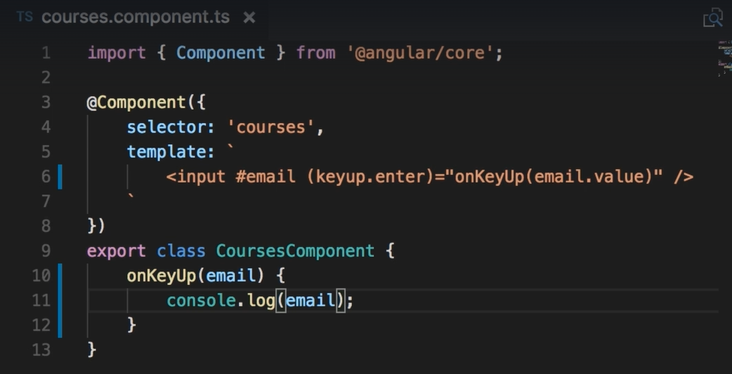

**Two-way binding**

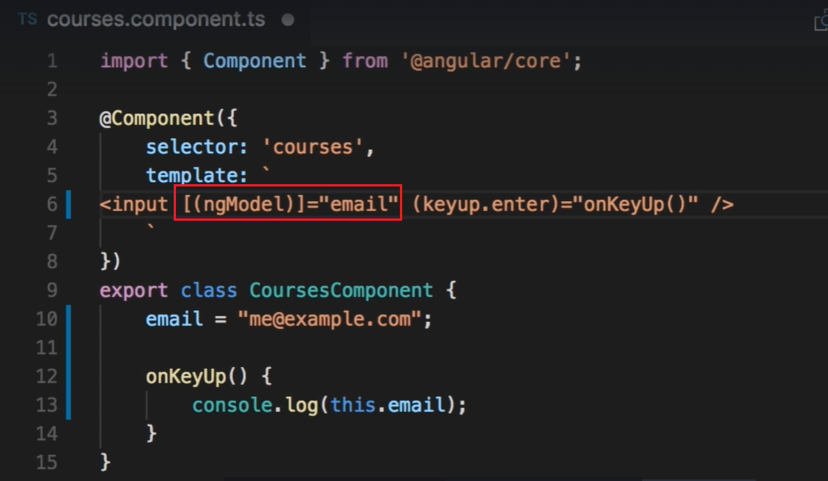

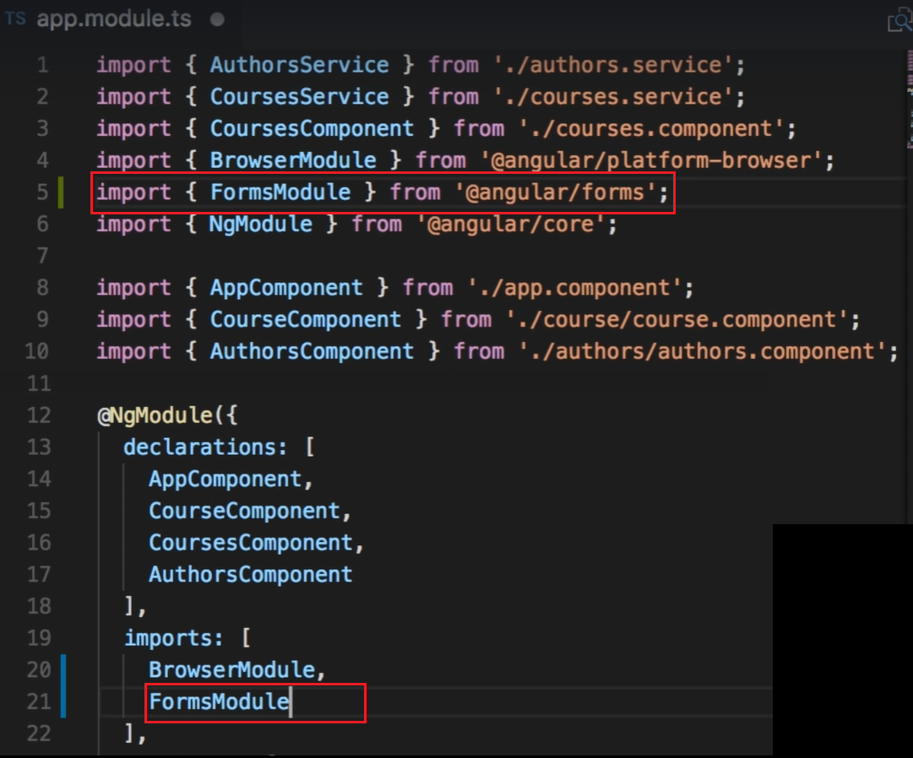

**Pipes**

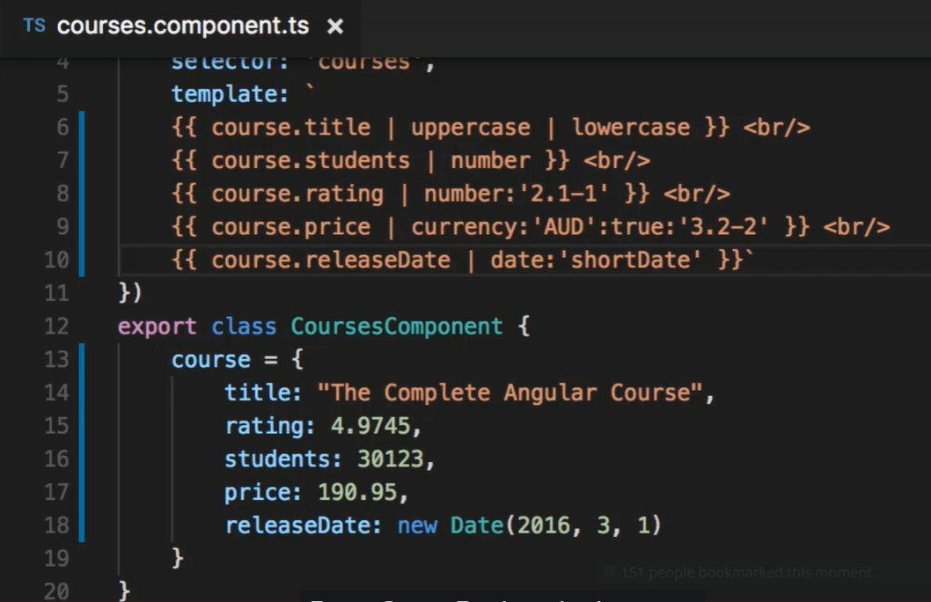

**Custom pipes**

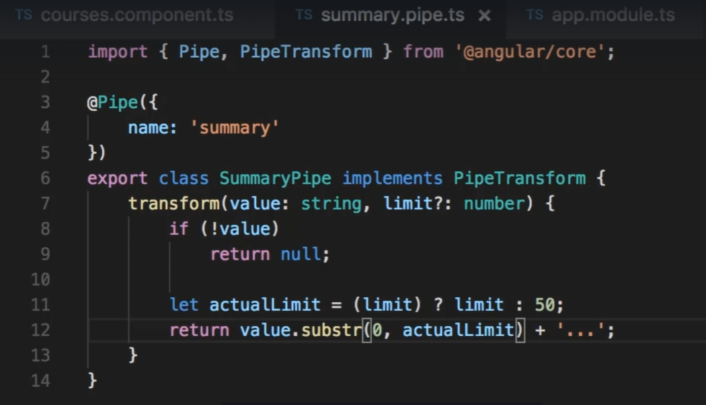

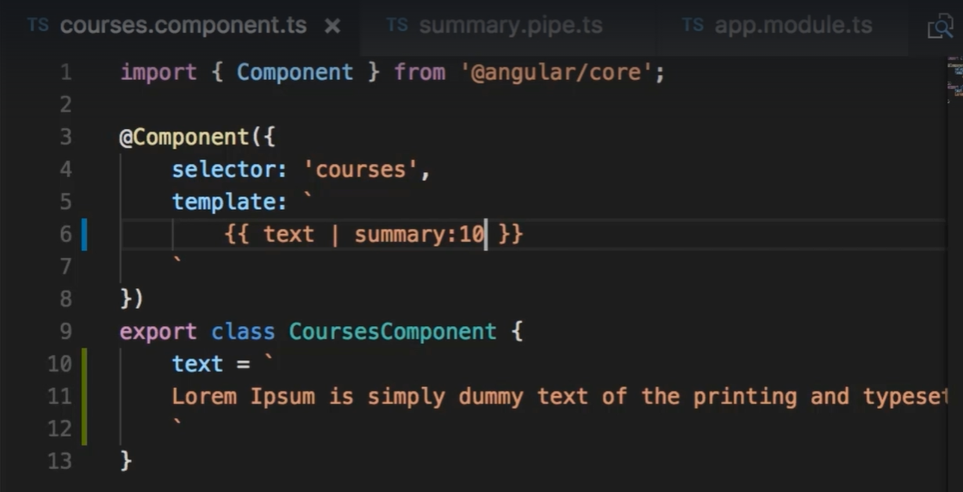

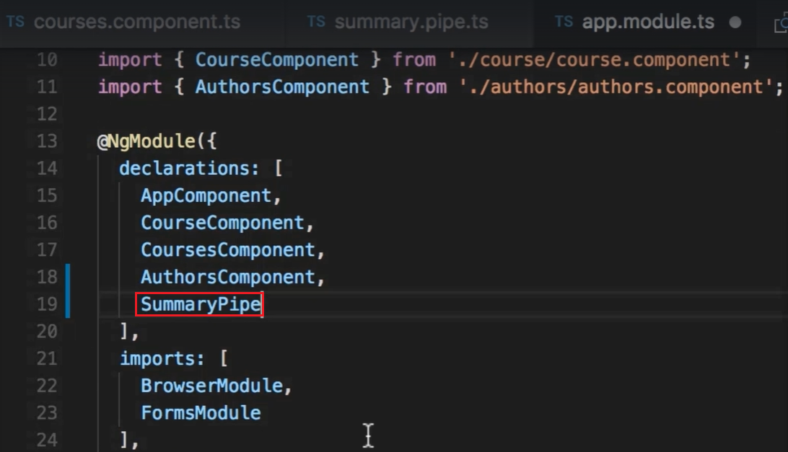

**Input Output Properties**

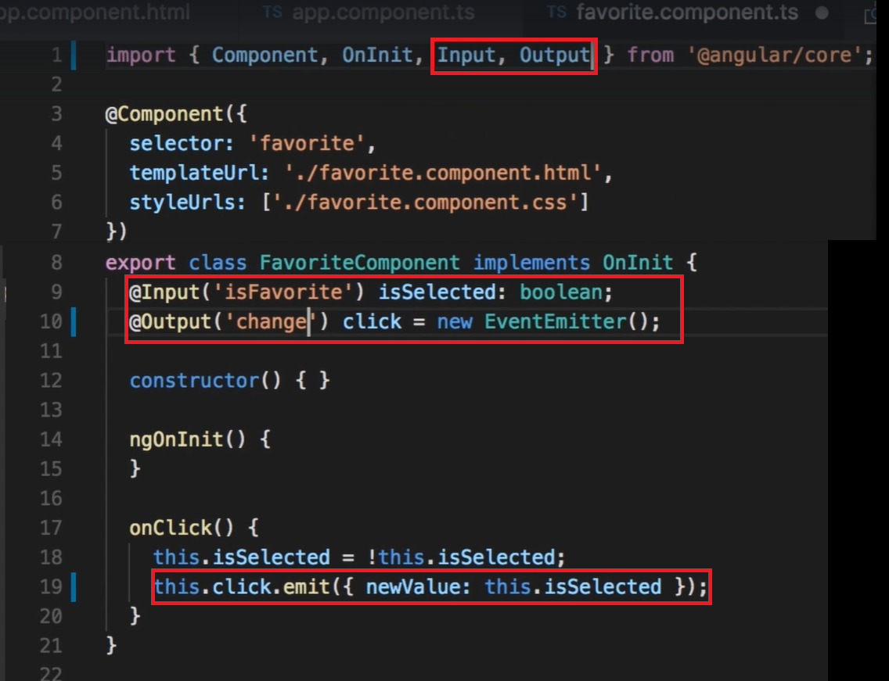

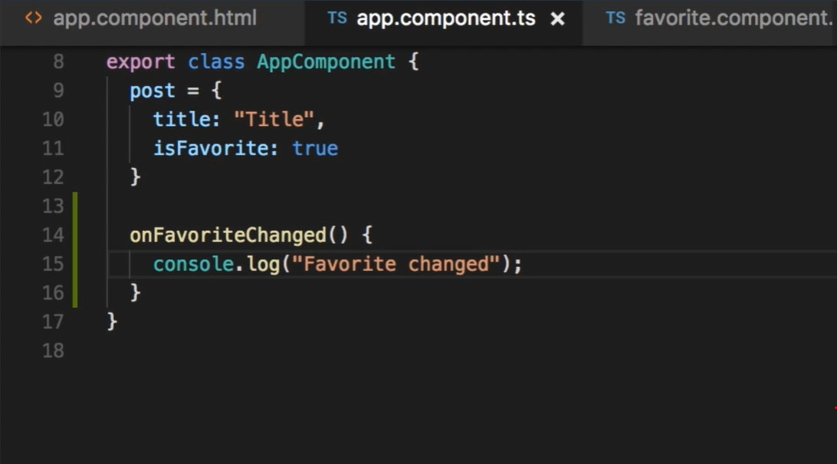

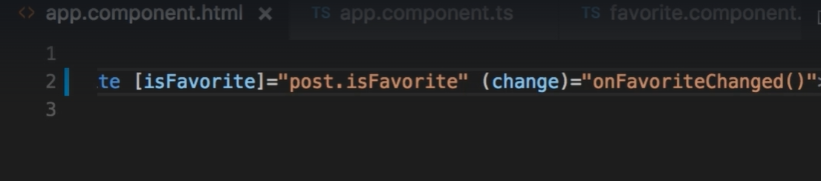

**Passing event data**

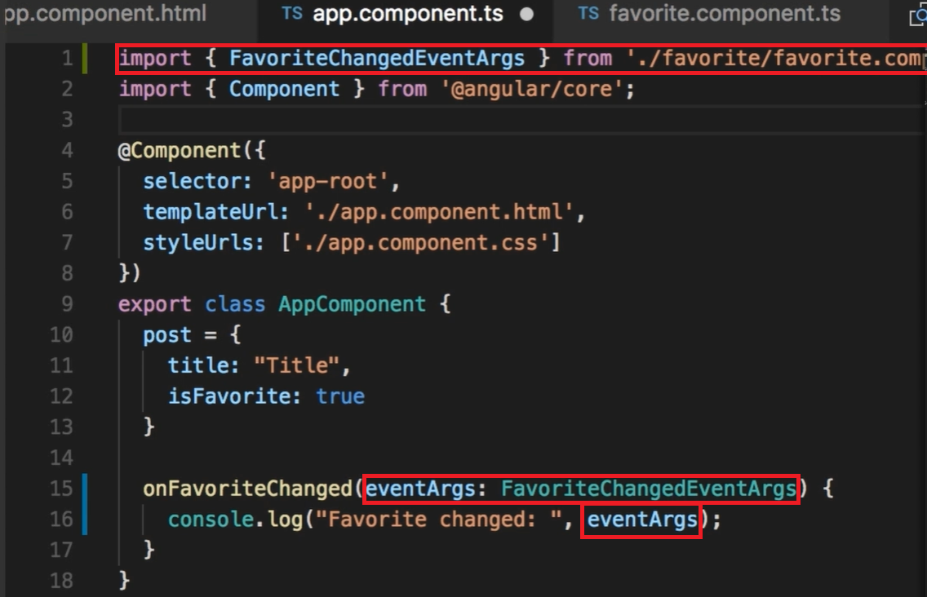

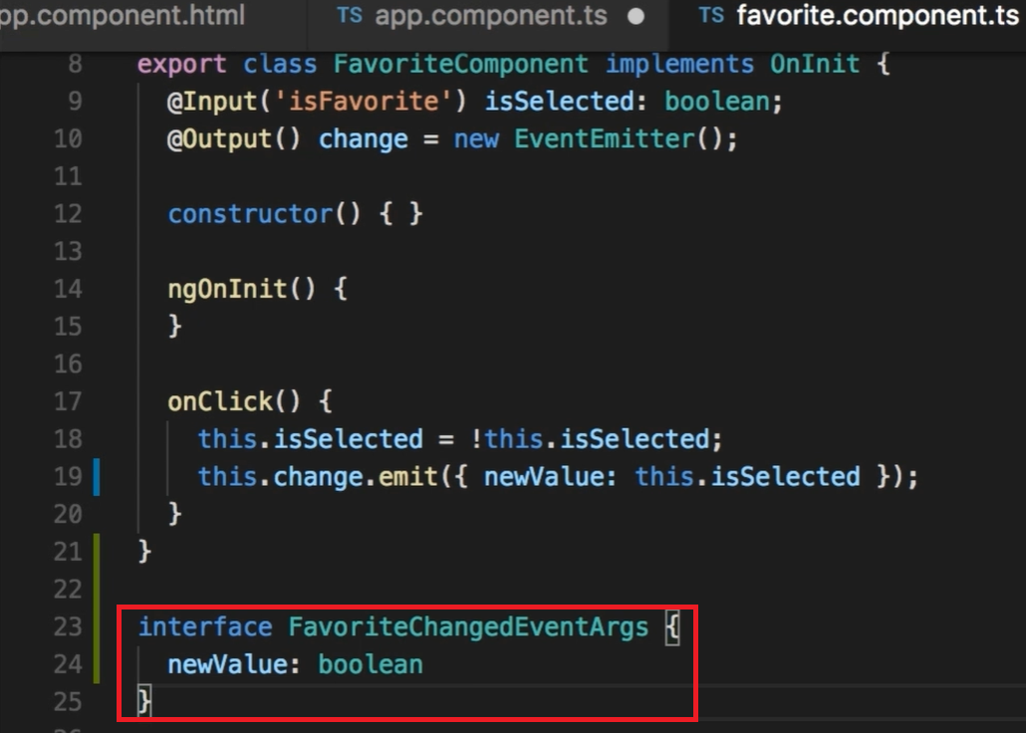

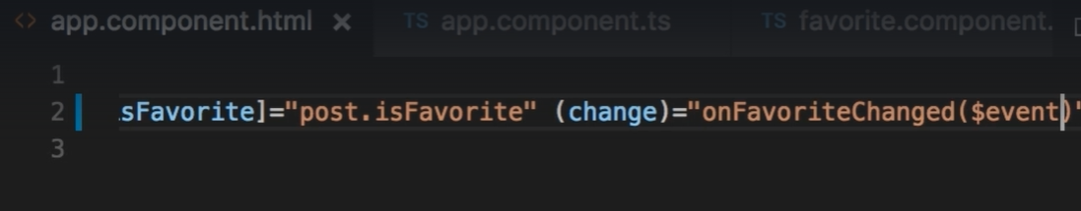

**View Encapsuation**

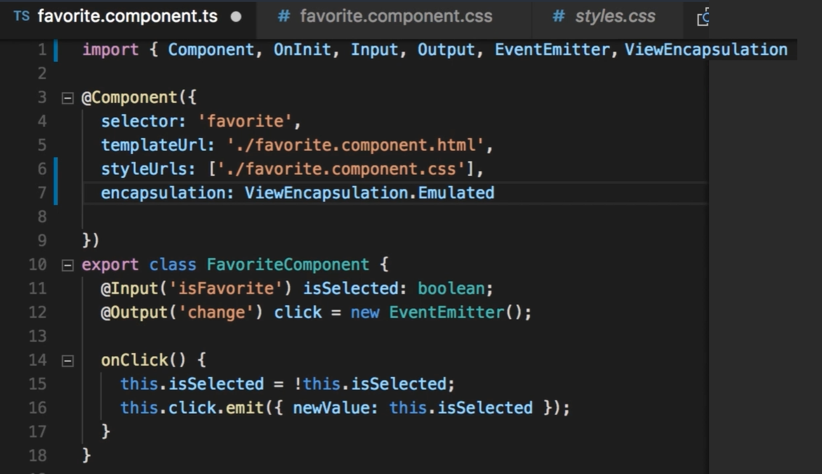

**NgContent –**  Replace div with div

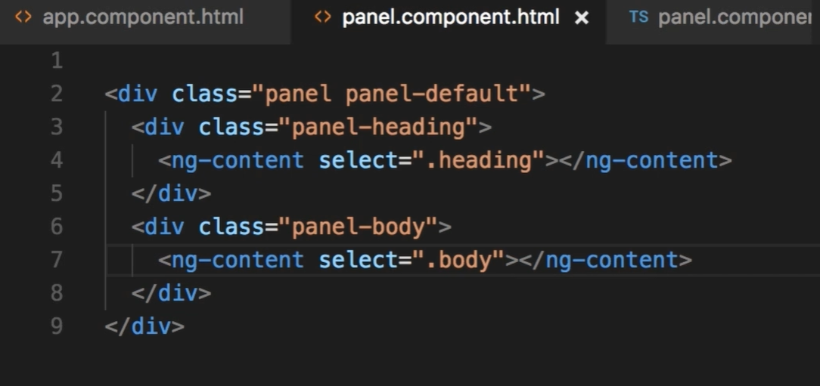 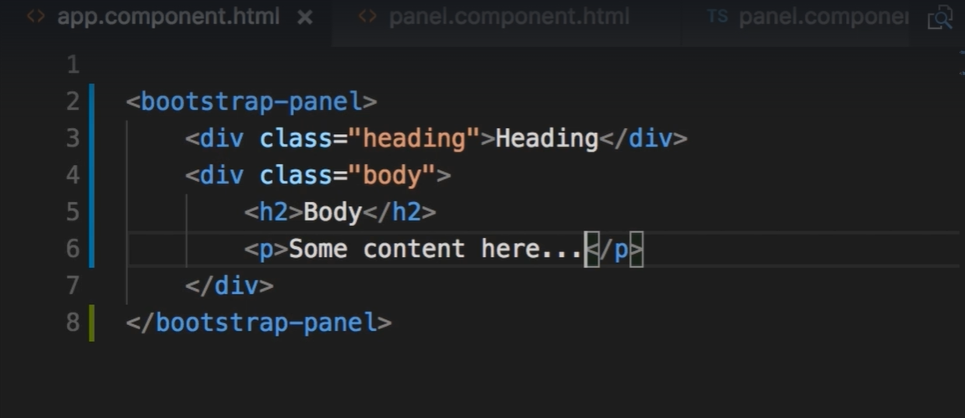

**ngContainer –**  Replace div with contents of div

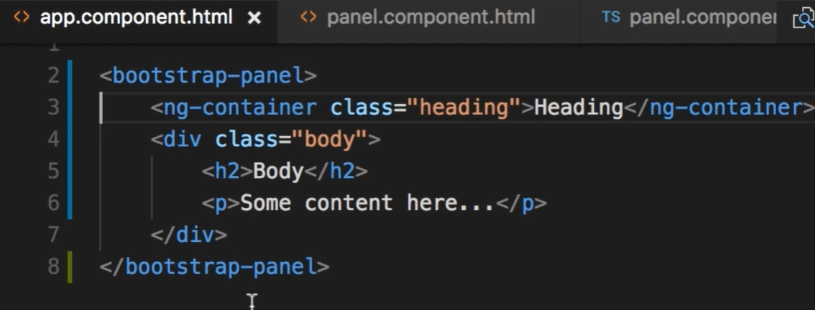

**Directives**

Ngif

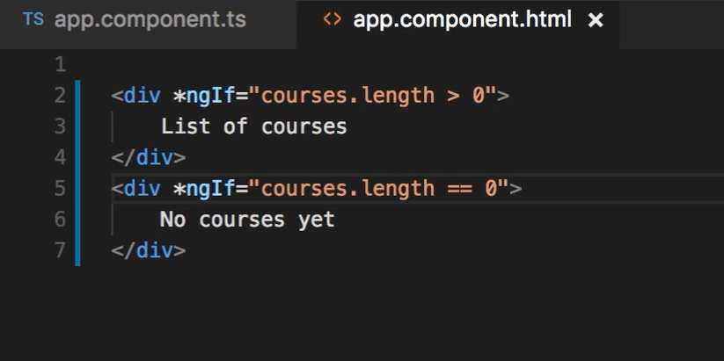

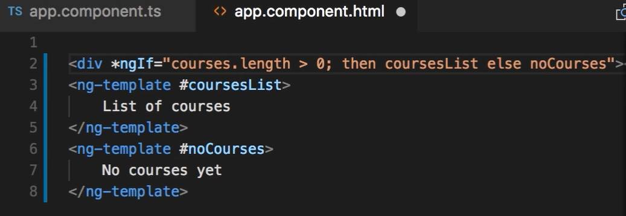

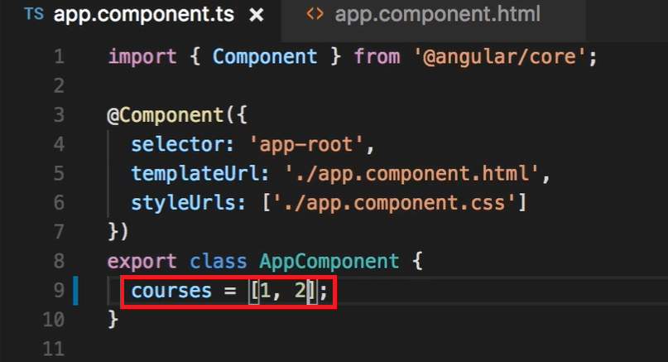

Hidden

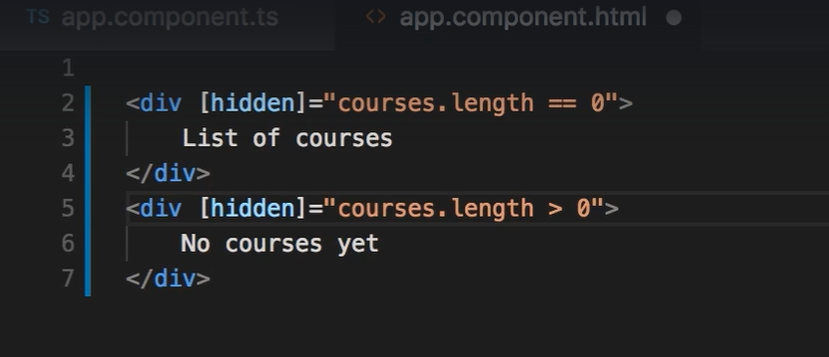

ngSwitchCase

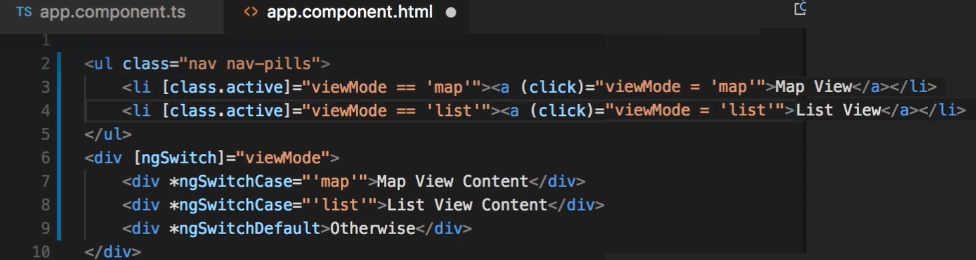

ngFor

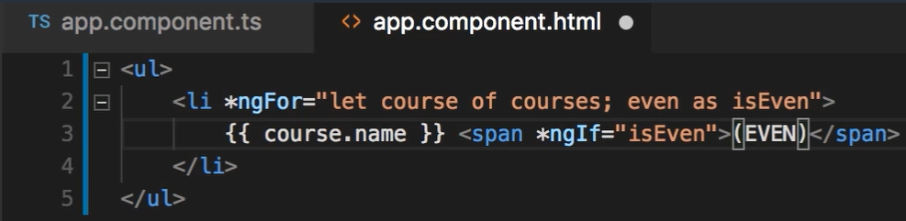

Change detection

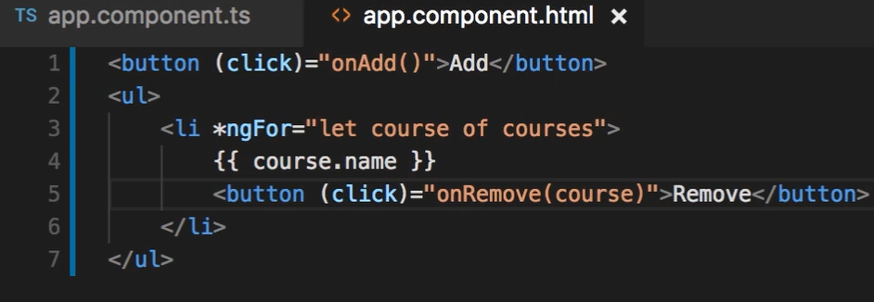

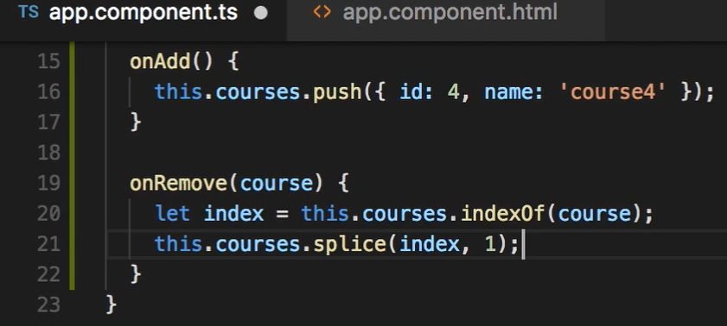

TrackBy

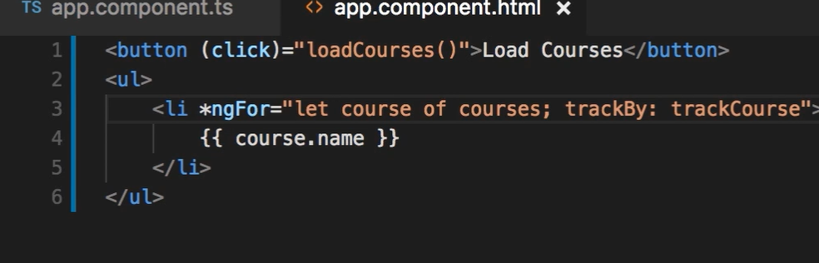

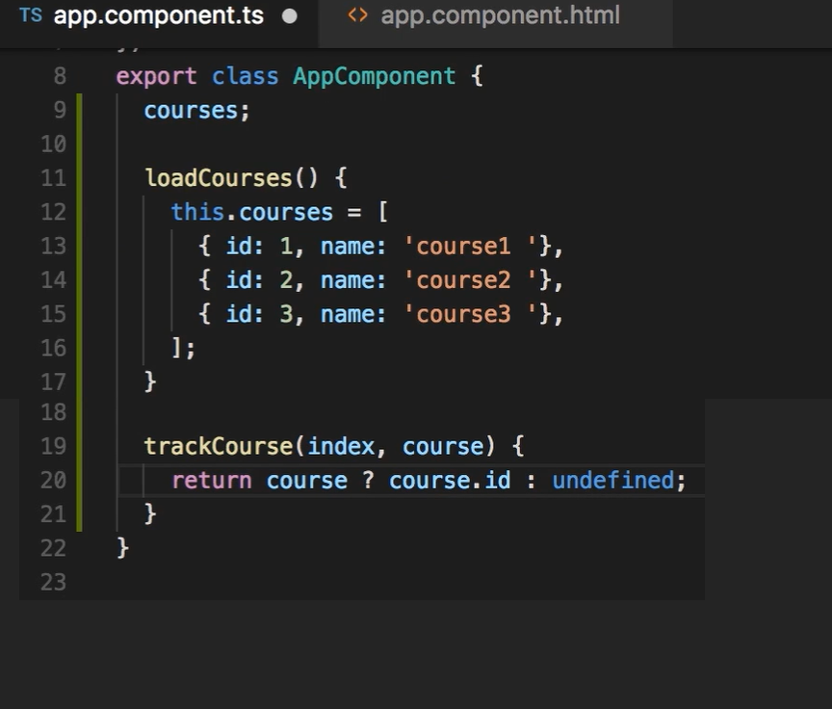

ngClass

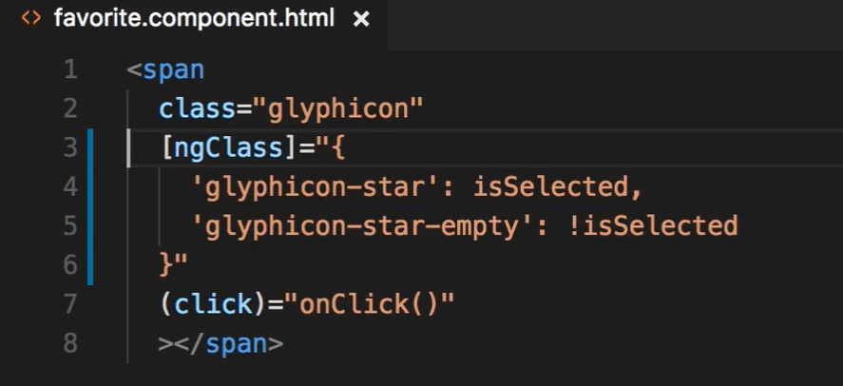

ngSwitch

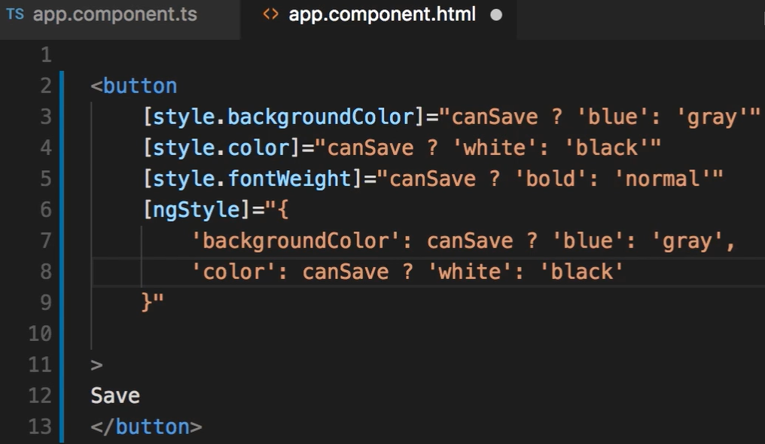

Safe Traversal

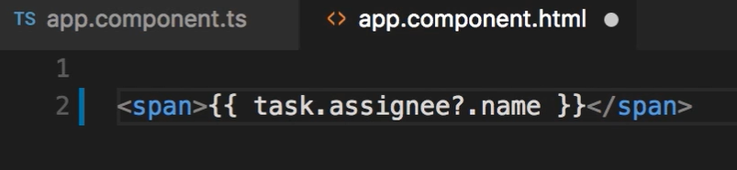

Creating custom directive

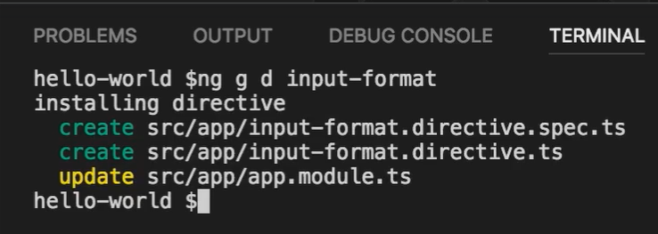

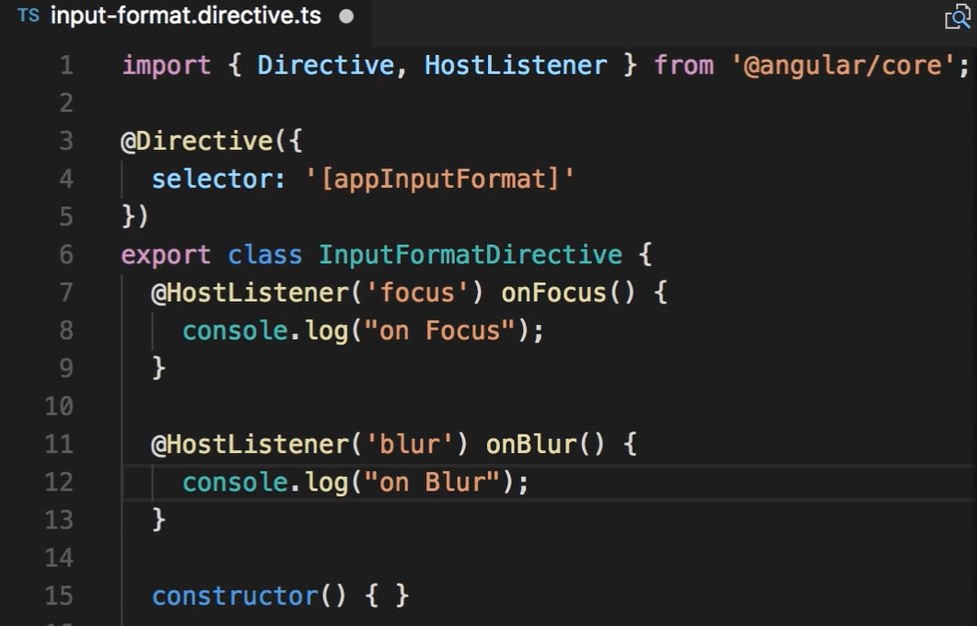

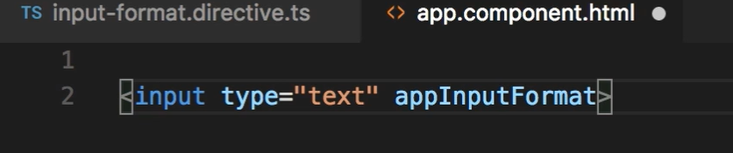

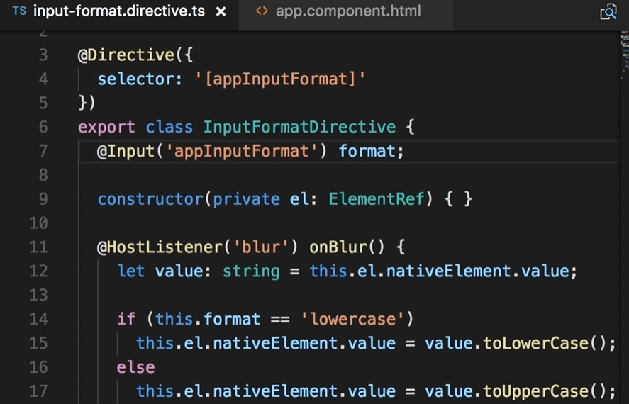

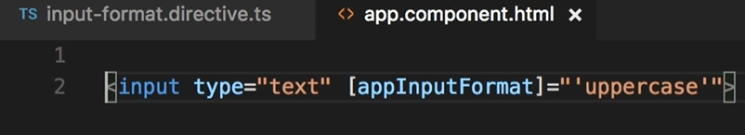

**Template driven form – ContactForm**

**contact-form.component.html**

<form name="myForm" #myForm="ngForm" (ngSubmit)="submit(myForm)" >

    <div ngModelGroup="contact" #contact="ngModelGroup" [class.formInvalid]="!contact.valid" >

        <div class="form-group">

            <label for="firstName">First Name</label>

            <input ngModel name="firstName"

                #firstName="ngModel" (change)="log(firstName)"

                id="firstName" type="text" class="form-control"

                required minlength="3" maxlength="15" pattern="^[A-Z a-z]+$"/>

            <div name="errorMsg" class="alert alert-danger"

                *ngIf="firstName.touched && !firstName.valid">

                <div *ngIf="firstName.errors.minlength">

                    First Name must have atleast {{firstName.errors.minlength.requiredLength}} characters

                </div>

                <div *ngIf="firstName.errors.required">

                    First Name is empty.

                </div>

                <div *ngIf="firstName.errors.pattern">

                    First Name can only have alphabets.

                </div>

            </div>

        </div>

        <div class="form-group">

            <label for="comment"> Comment </label>

            <textarea ngModel name="comment" id="comment"

                class="form-control" cols="30" rows="10">

            </textarea>

        </div>

        <div *ngFor="let gender of genders" class="radio">

            <label for="gender">

                <input ngModel name="gender" type="radio"  [value]="gender">{{gender.name}}

            </label>

        </div>

        <div>

            <label>

                <input ngModel name="isSubscribed" type="checkbox" >

                Subscribe for mail alerts

            </label>

        </div>

        <div class="form-group">

            <label for="contactMethod"> Contact Method </label>

    <select ngModel name="contactMethod" id="contactMethod" class="form-control">

                <option *ngFor="let method of contactMethods" [ngValue]="method"> {{method.name}} </option>

            </select>

        </div>

    </div>

    <p>{{myForm.value | json}}</p>

    <button type="submit" [disabled]="!myForm.valid" class="btn btn-primary"> Submit </button>

</form>

**style.css**

@import "~bootstrap\dist\css\bootstrap.css";

body{padding:20px}

.form-control.ng-touched.ng-invalid {

    border: 1.5px solid red;

}

.formInvalid{

    color:   red;

}

**contact-form.component.ts**

import { Component, OnInit, NgModule } from '@angular/core';

@Component({

  selector: 'contact-form',

  templateUrl: './contact-form.component.html',

  styleUrls: ['./contact-form.component.css']

})

export class ContactFormComponent {

  genders = [{id:1, name:"Male"},{id:2, name:"Female"}];

  contactMethods= [{id:1, name:"Phone"},{id:2, name:"SMS"},{id:3, name:"EMail"}];

  log(x) {

console.log(x);

}

  submit(x) {

console.log(x);

}

}

**Reactive form – SignUpForm**

**signup-form.component.html**

<form [formGroup]="form" (ngSubmit)="login()">

    <div formGroupName="account">

        <div class="form-group">

            <label for="username">Username</label>

            <input

                formControlName="username"

                id="username"

                type="text"

                class="form-control">

            <div *ngIf="username.pending">Checking username on server...</div>

            <div *ngIf="username.touched && username.invalid"

                class="alert alert-danger">

                <div *ngIf="username.errors.required">

                    Username cannot be empty.

                </div>

                <div *ngIf="username.errors.cannotContainSpace">

                    Username cannot have a space.

                </div>

                <div *ngIf="username.errors.email">

                    Username must be a valid email address.

                </div>

                <div *ngIf="username.errors.shouldBeUnique">

                    Username is already taken.

                </div>

            </div>

        </div>

        <div class="form-group">

            <label for="password">Password</label>

            <input

                formControlName="password"

                id="password"

                type="text"

                class="form-control">

            <div *ngIf="password.touched && password.invalid"

                class="alert alert-danger">

                <div *ngIf="password.errors.required">

                    Password cannot be empty.

                </div>

                <div *ngIf="password.errors.minlength">

                    Password must be of atleast 8 characters.

                </div>

            </div>

        </div>

        <button class="btn btn-primary" type="submit">Sign Up</button>

        <br>

        <br>

        <div *ngIf="form.errors"class="alert alert-danger">

                The username or password is invalid

        </div>

    </div>

</form>

**signup-form.component.ts**

import { Component } from '@angular/core';

import { FormGroup, FormControl, Validators} from '@angular/forms';

import { UsernameValidators } from './username.validators';

@Component({

  selector: 'signup-form',

  templateUrl: './signup-form.component.html',

  styleUrls: ['./signup-form.component.css']

})

export class SignupFormComponent {

  form = new FormGroup({

    account : new FormGroup({

      username: new FormControl('', [

          Validators.required,

          Validators.email,

          UsernameValidators.cannotContainSpace

        ],

        UsernameValidators.shouldBeUnique

      ),

      password: new FormControl('', [

        Validators.required,

        Validators.minLength(8)

      ])

    })

  });

  get username()  { return this.form.get('account.username'); }

  get password() { return this.form.get('account.password'); }

login()  {

    /*

    let isValid = authService.login(this.form.value);

    if(!isValid)

    {

      this.form.setErrors({

        invalidLogin: true

      });

    }*/

    this.form.setErrors({invalidLogin: true });

  }

}

**username.validators.ts**

import { AbstractControl, ValidationErrors } from '@angular/forms';

import { resolve } from 'url';

export class UsernameValidators

{

    static cannotContainSpace(control : AbstractControl) : ValidationErrors | null

    {

        if((control.value as string).indexOf(' ') >= 0)

        {

            return { cannotContainSpace: true}

        }

    }

    static shouldBeUnique(control : AbstractControl) : Promise<ValidationErrors | null>

    {

        return new Promise((resolve,reject) =>

        {

            setTimeout(()=> {

                if(control.value == 'abc@xyz.com')

                    resolve({shouldBeUnique: true});

                else

                    resolve(null);

            },2000);

        });

    }

}

FormArray

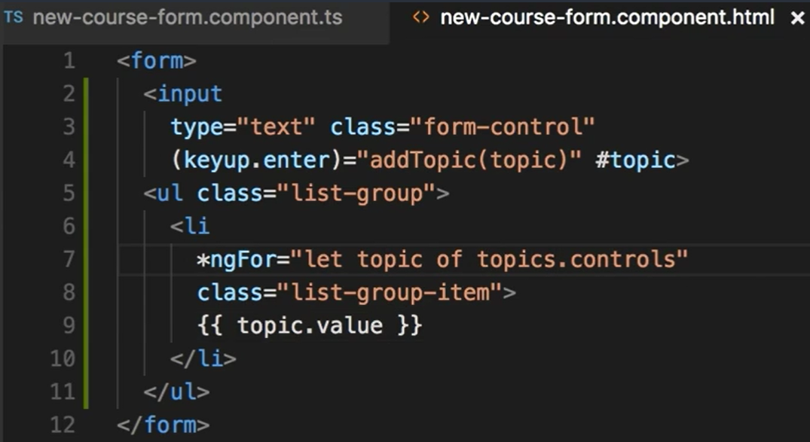

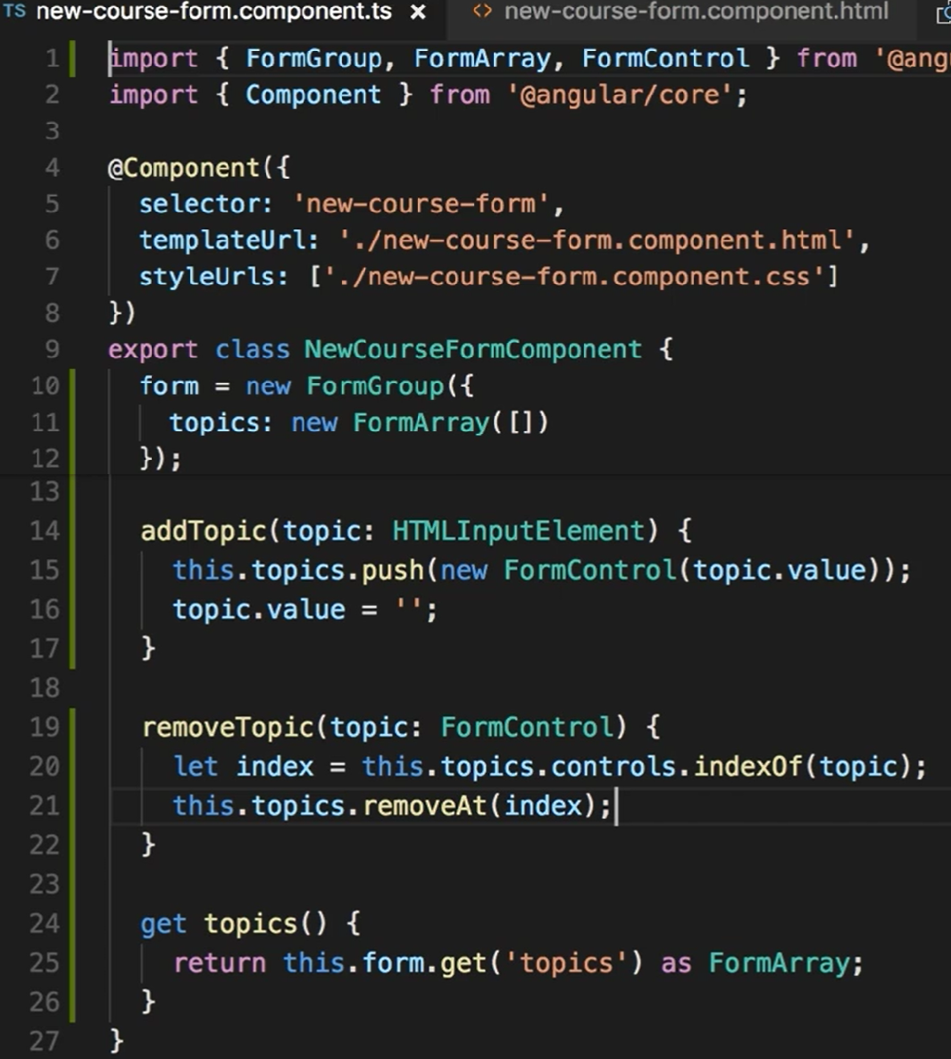

FormBuilders

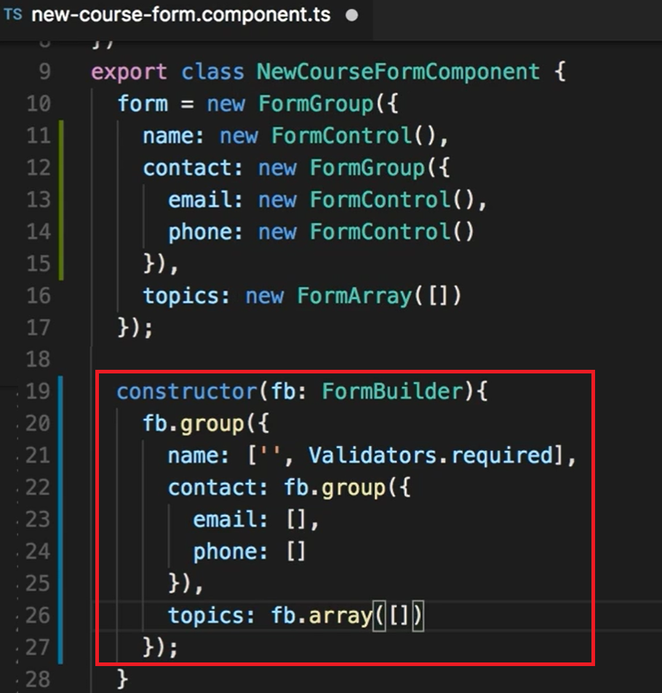

HTTP methods

Creating service

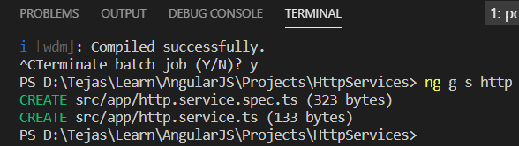

Make directory folder

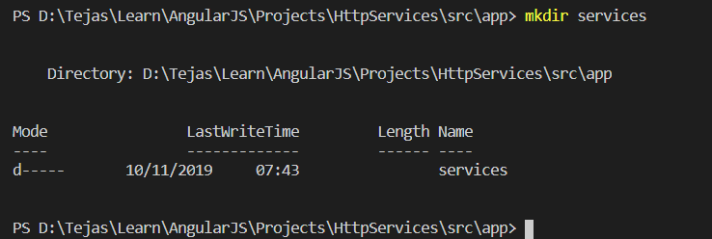

Move service files to different folder

